(e) Using your knowledge of the whole period of study, evaluate the importance of the themes, ideas and/or events in the four sources. (7 marks)

Explain the message of Source 3. (3 marks)

Document Set 1B: Australia 1918-1955

Source 1
Extract from a radio broadcast speech by Prime Minister Robert Menzies, September 3 1939

“Fellow Australians, it is my melancholy duty to inform you officially that, in consequence of the persistence of Germany in her invasion of Poland, Great Britain has declared war upon her, and that, as a result, Australia is also at war…
Bitter as we all feel at this wanton crime, this is not a moment for rhetoric; prompt as the action of many thousands must be, it is for the rest a moment for quiet thinking; for that calm fortitude which rests not upon the beating of drums, but upon the unconquerable spirit of man, created by God in His own image. What may be before us we do not know, nor how long the journey. But this we do know, that Truth is our companion on that journey; that Truth is with us in the battle, and that Truth must win...
Before I end, may I say this to you? In the bitter months that are to come, calmness, resoluteness, confidence and hard work will be required as never before. This war will involve not only soldiers and sailors and airmen, but supplies, foodstuffs, money. Our staying power, and particularly the staying power of the mother country, will be best assisted by keeping our production going; by continuing our avocations* and our business as fully as we can; by maintaining employment and with it our strength.”

*avocations – going about one’s everyday normal activities and business

Source 2
Poster and newspaper insert produced by the Commonwealth Government of Australia, 1943

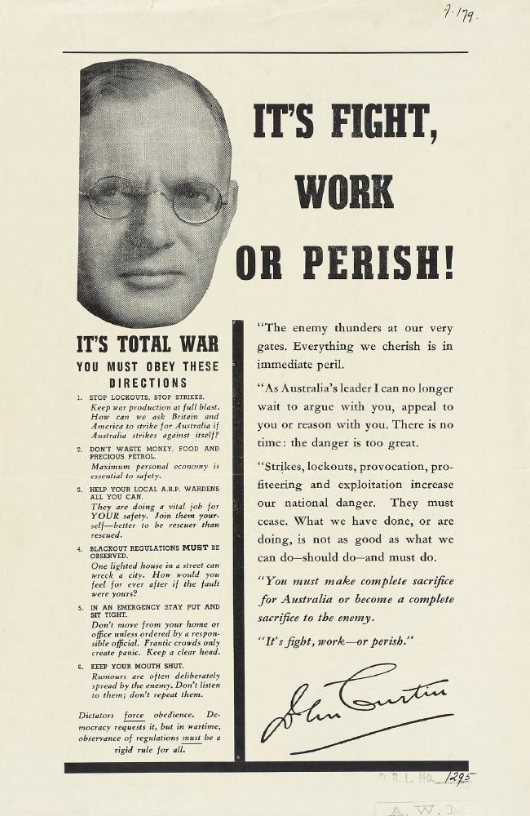

Source 3

Propaganda poster produced by the Commonwealth Government of Australia, from 1943.

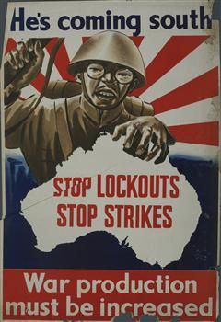

Source 4

Extract from “War on the Homefront State intervention in Queensland 1938-1948” by Kay Saunders (1993). Dr Saunders is an associate professor and reader in history at University of Queensland. She has published widely in the fields of race relations, gender studies, war and society studies and the federation of Australia.

“…As hostilities became entrenched and the war escalated from limited involvement aiding the British effort on distant battle zones, to an immediate direct threat of invasion which prompted hitherto unprecedented centralisation and authoritarian measures to deal with die crisis, civil liberties were stringently, if unevenly, curtailed. As later chapters will demonstrate, Australian society became obsessively intent upon identifying and punishing diose perceived to be potentially undermining national security, the war effort or morale: Enemy aliens, communists, members of the Australia First Movement or women sexually involved with Allied servicemen were all placed under scrutiny and often incarcerated. Wartime governments made extensive use of covert or informal strategies to restrict civil liberties and attempt to manipulate public opinion. But these strategies were rarely based on the possible use of emergency powers. They relied on the ability of government to intervene in more discreet, subtle ways”

